  

**NAME : ZOHO BOOKS**

**PROJECT TITLE : ZOHO BOOKS FOR TRAVEL**

**TRAK TOURS**

**PROJECT SUBMITTED : SMART INTERNZ**

**YEAR : III**

**DEPARTMENT : COMMERCE & CA**

**SEMESTER : V**

**GROUP ID : NM2023TMID18097**

**MEMBERS OF THE GROUP : G.VISHAL**

**K.VISHVA**

**M.VIVEKANDADAN**

**K.PALPANDIYAN**

**GUIDED BY : VAIRAMUTHUSELVI M**

**SPOC NAME : EZHIL VENDHAN R**

**PREPARATION AND MAINTANCE OF ZOHO BOOKS FOR TRAVAL TRAK TOURS**

**SETP 1**

**Created a organization profile**

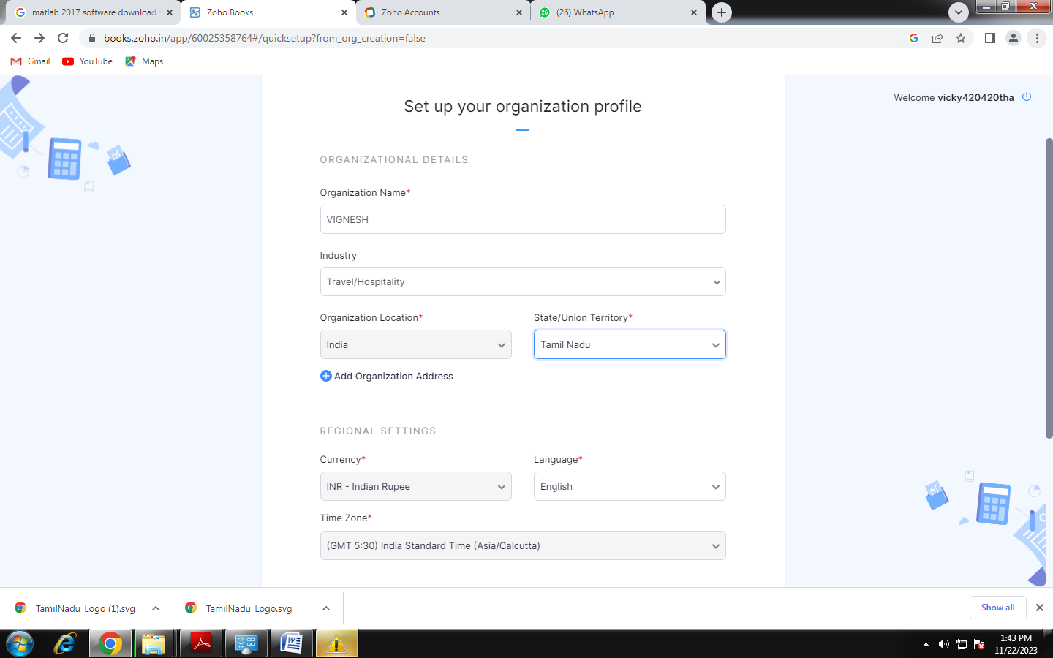

STEP NO: 2

CLICK ON THE OK BUTTON

STEP 3

CREATED A ITEMS

SUGARAJ TRAVAL CREATED A COMPANY

ENTER THE SELLING PRICE AND COST OF PURCHASE

SAVE THE BUTTON

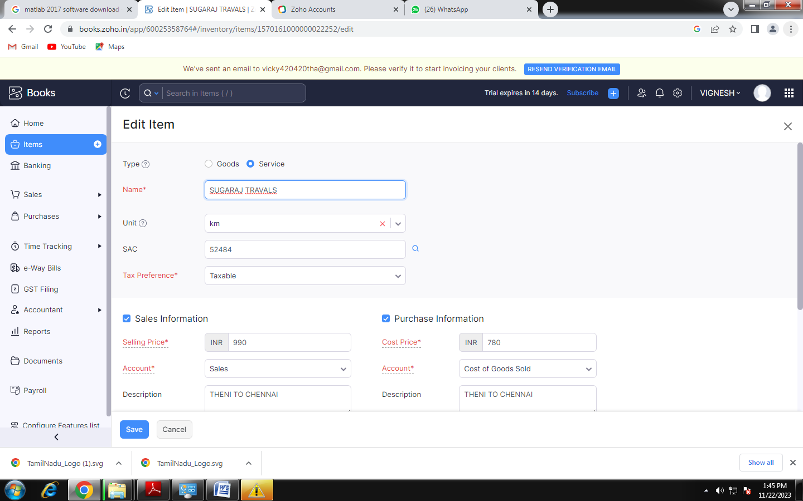

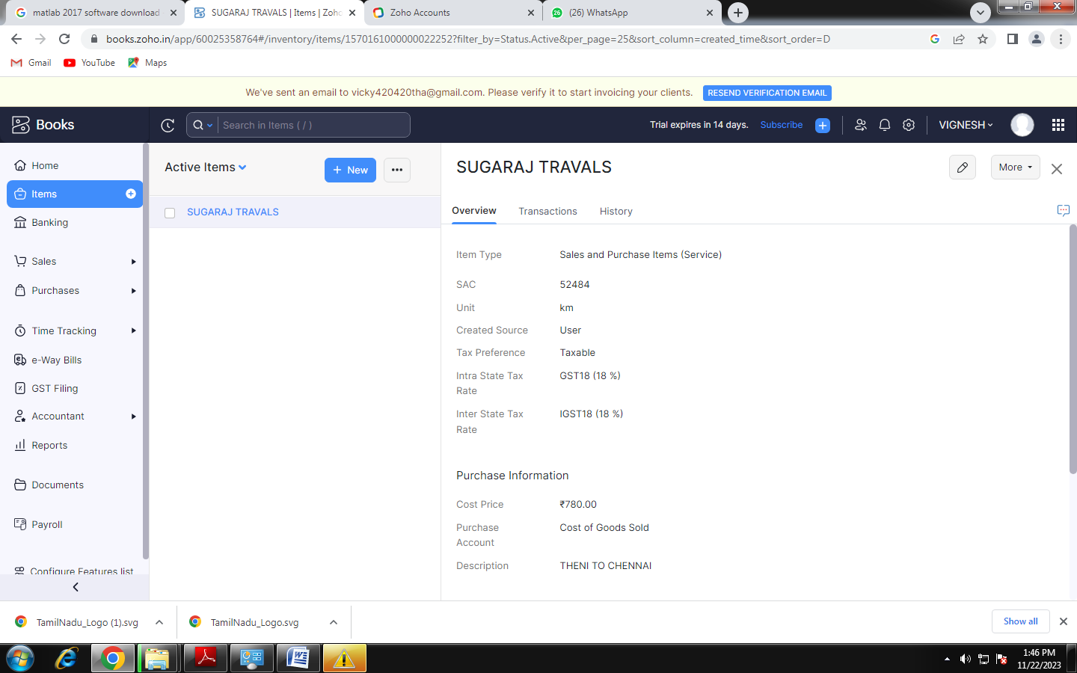

STEP 4

ADD A CUSTOMER NAME

ENTER THE CUSTOMER NAME

ENTER THE PHONE NUMBER

ENTER THE UN ORGANIZED BUSINESS

CLICK ON THE SAVE BUTTON

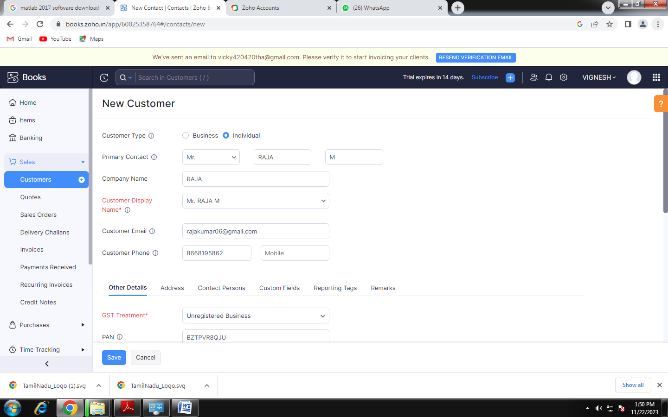

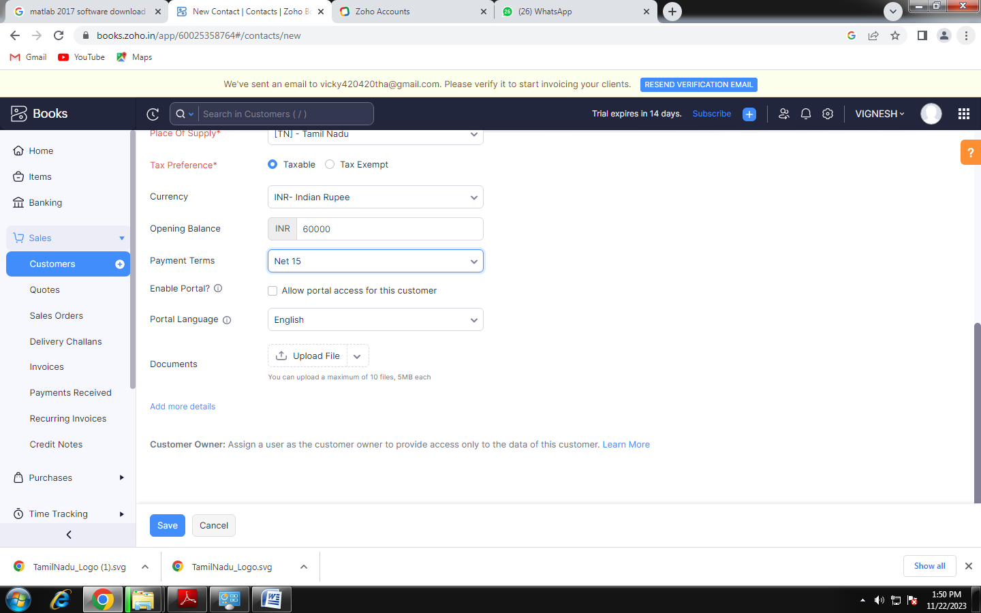

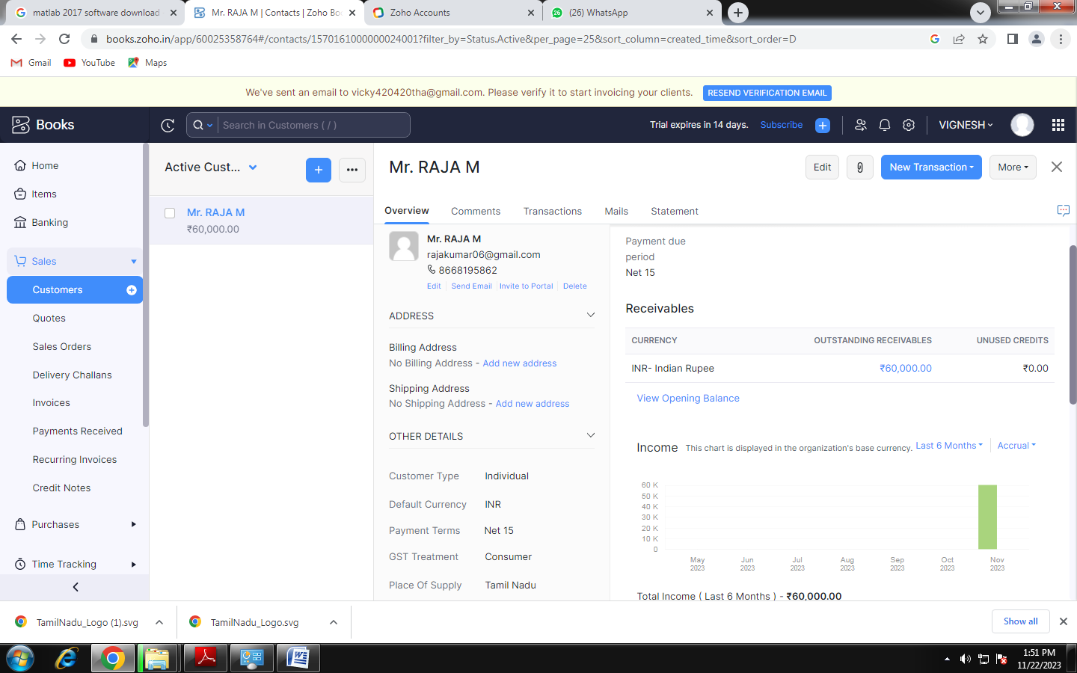

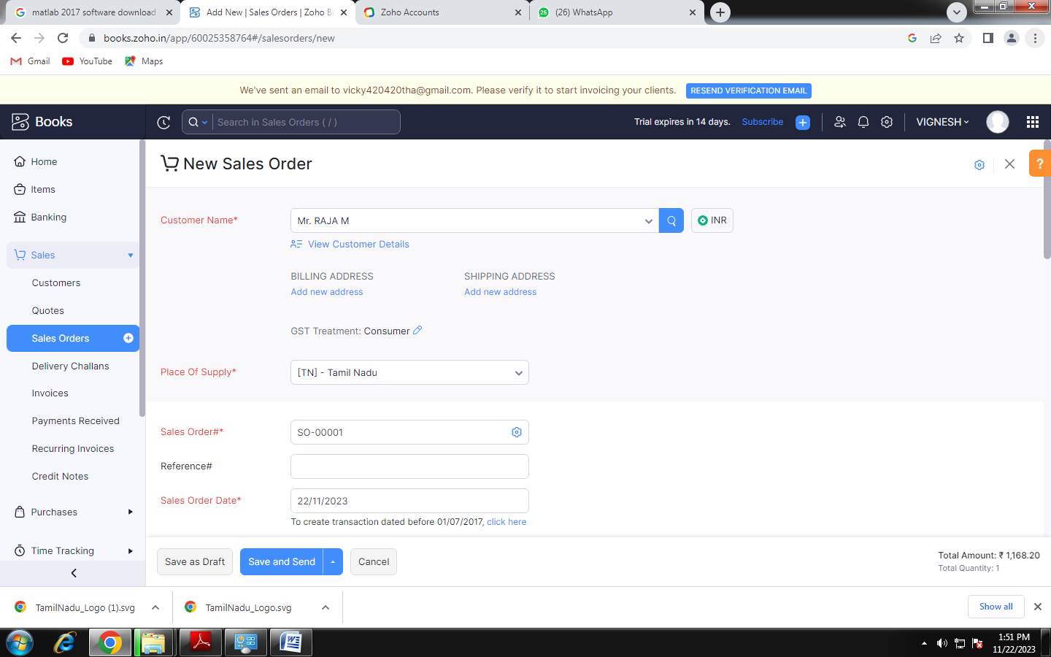

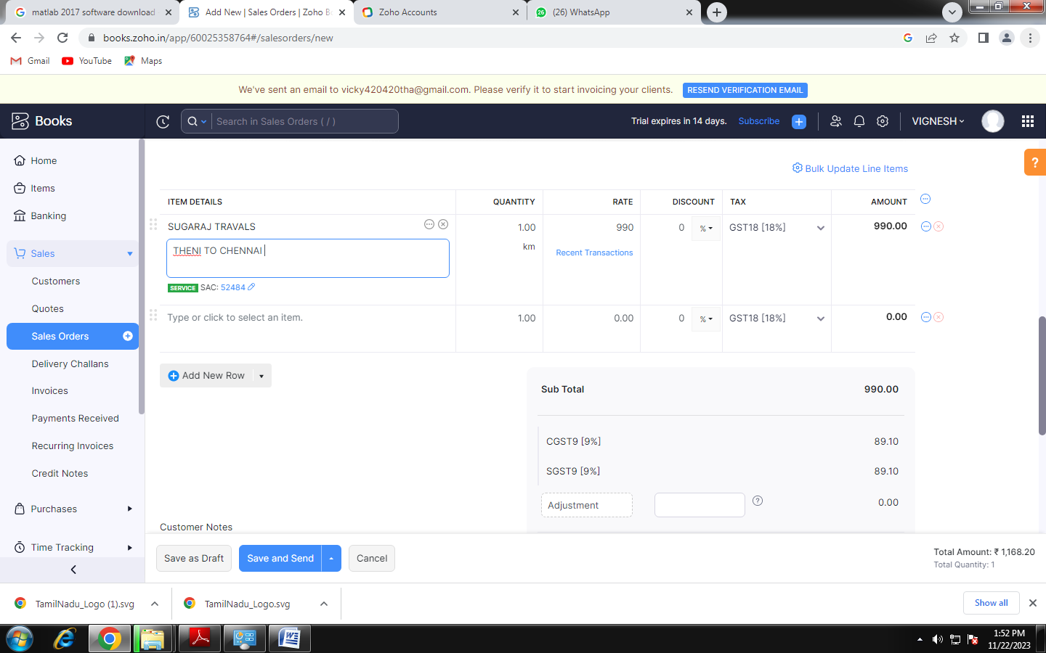

FINISHED THE THEIN TO CHENNI BUS TICKET BOOKED